**Analysis and Findings**

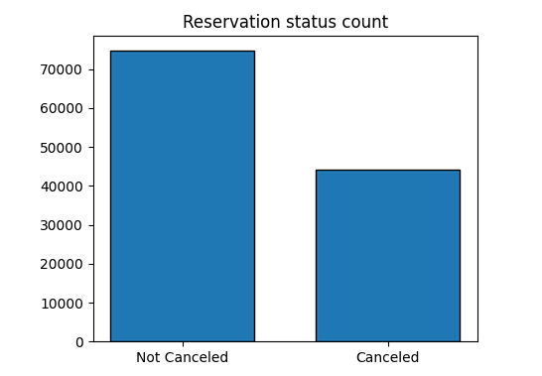

* The accompanying bar graph shows the percentage of reservations that are canceled and those that are not. It is obvious that there are still a significant number of reservations that have not been canceled. There are still 37% of clients who canceled their reservation, which has a significant impact on the hotel’s earnings.

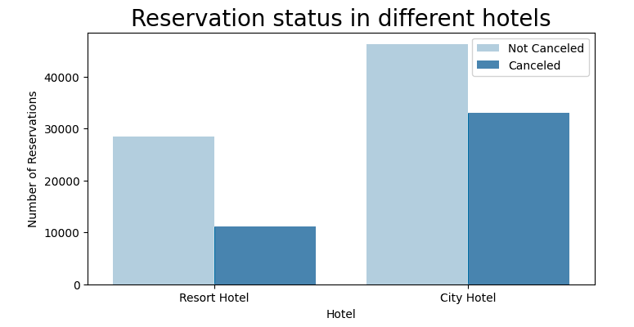

* In comparison to resort hotels, city hotels have more bookings. It’s possible that resort hotels are more expensive than those in cities.

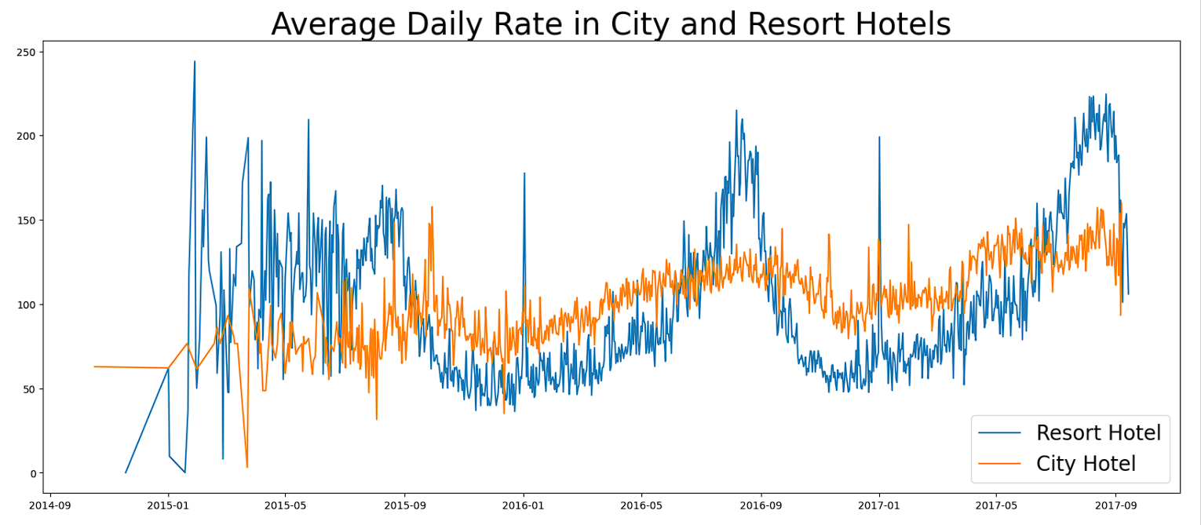

* The line graph above shows that, on certain days, the average daily rate for a city hotel is less than that of a resort hotel, and on other days, it is even less. It goes without saying that weekends and holidays may see a rise in resort hotel rates.

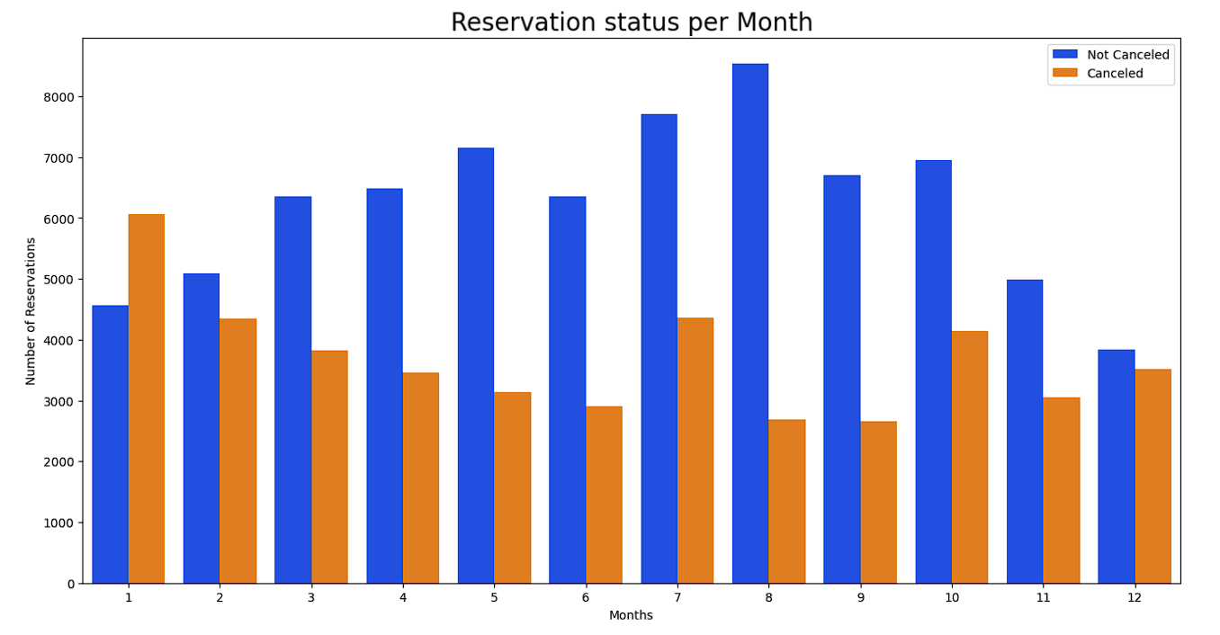

* We have developed a grouped bar graph to analyze the months with the highest and lowest reservation levels according to reservation status. As can be seen, the number of confirmed reservations are the highest and the number of canceled reservations are the lowest in the month of August, whereas January is the most canceled reservations.

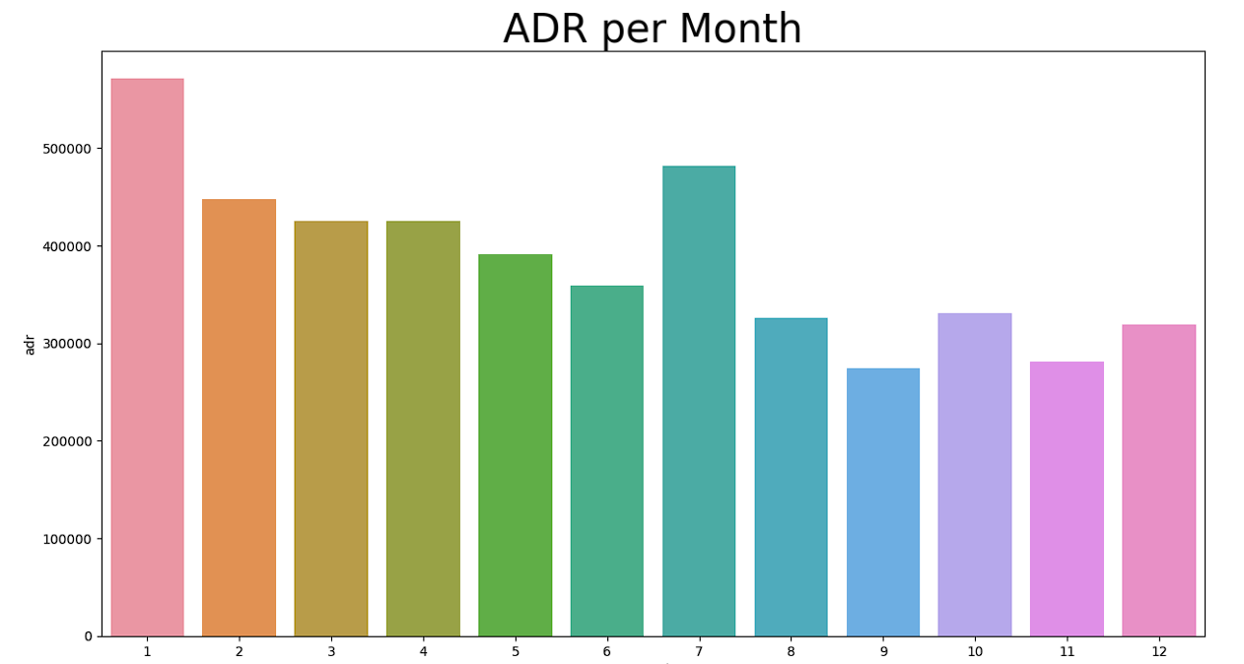

- This bar graph demonstrates that cancellations are most common when prices are highest and are least common when they are lowest. Therefore, the cost of the accommodation is solely responsible for the cancellation.

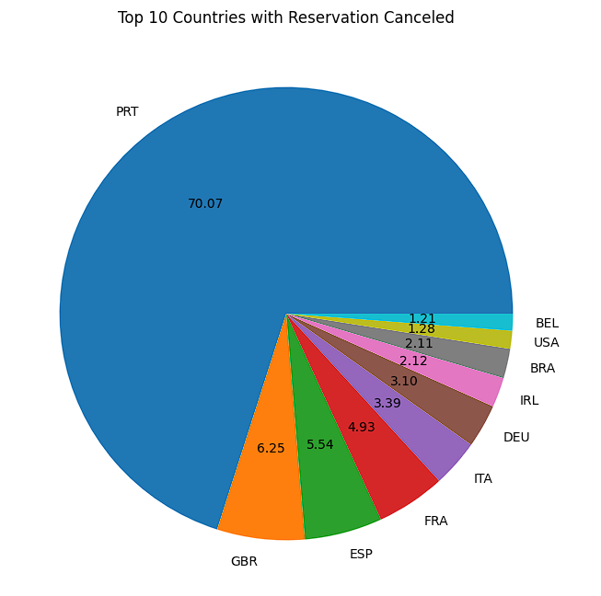

* Now, let’s see which country has the highest reservation canceled. The top country is Portugal with the highest number of cancellations.
* Let’s check the area from where guests are visiting the hotels and making reservations. Is it coming from Direct or Groups, Online or Offline Travel Agents? Around 46% of the clients come from online travel agencies, whereas 27% come from groups. Only 4% of clients book hotels directly visiting them and making reservations.

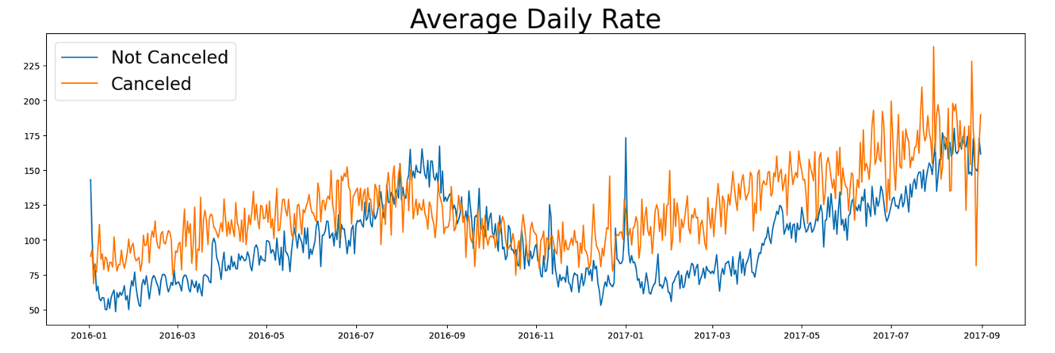

* As seen in the graph, reservations are canceled when the average daily rate is higher than when it is not canceled. It clearly proves all the above analysis, that the higher price leads to higher cancellations.

**Suggestions**

1. Cancellation rates rise as the price does. In order to prevent cancellations of reservations, hotels should work on their pricing strategies and try to lower the rates for specific hotels based on locations. They can also provide some discounts to the consumers.
2. As the ratio of the cancellation and not cancellation of the hotel is higher in the resort hotel than city hotel. So the hotels should provide a reasonable discount on the room prices on weekends or on holidays.
3. In the month of January, hotels can start campaigns or marketing with a reasonable amount to increase their revenue as the cancellation is the highest in this month.
4. They can also increase the quality of their hotels and their services mainly in Portugal to reduce the cancellation rate.